OCP: Optimized Co-registration Package

Program User’s Guide (Version 1.0)

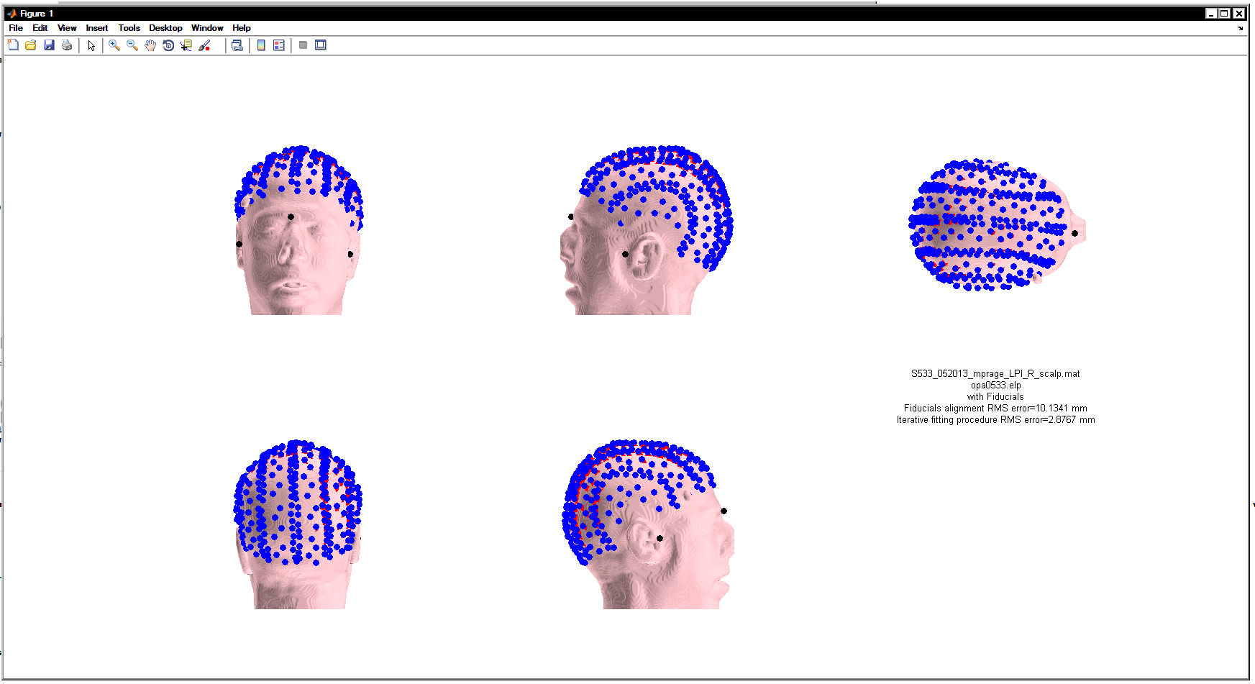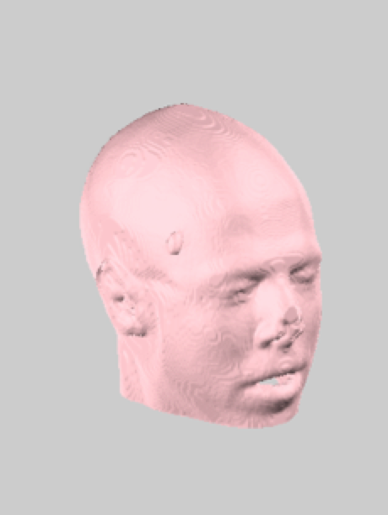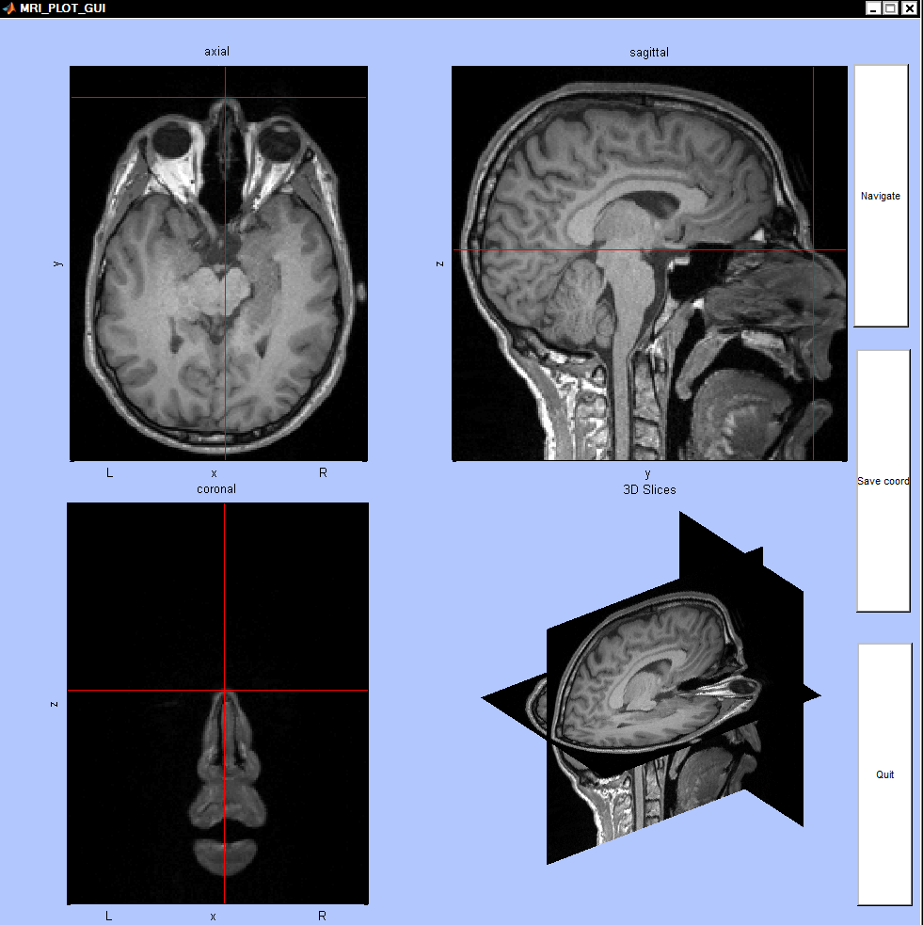

Copyright © 2014, Chiarelli Antonio Maria, Beckman Institute of Technology, University of Illinois at Urbana Champaign.

Optimized Co-registration Package (OCP) is free software; you can distribute it and/ or modify it under the terms of the GNU General Public License (GPL) as publishing by the Free Software Foundation, either version 3 of the License, or any later version.

Additional Note from Authors

You can get the software freely – including source code – by downloading it. We appreciate if you cite the following papers in producing the results using OCP toolbox. (Comparison of procedures for co-registering scalp-recording locations to anatomical magnetic resonance images. Chiarelli et al., 2015)

OCP is a MATLAB-based software package that allows from raw structural MRI images and digitized points on the scalp surface to accurately co-register these points to an extracted scalp surface of an MRI image and store these points in a real MRI space. Moreover, it is possible to save these points into standard spaces like MNI ICBM-152 and Talairach templates. Different algorithm are implemented in the toolbox to achieve a correct and stable co-registration procedure like, fiducials alignment, iterative surface fitting algorithms (LMA, ICP2P) and scalp forcing (refer Chiarelli et al., 2015).

MATLAB- based software

**How to start**

In order to run OCP, MATLAB and spm8 software should be available on your system.

Please download the spm8 from, http://www.fil.ion.ucl.ac.uk/spm/software/spm8/

Then, add 1) OCP with sub-folders, 2) spm8 directories with sub- folders in the MATLAB path.

Start up MATLAB and type “OCP” at the MATLAB command window. The main panel of OCP will then open. Analysis takes place in different stages.

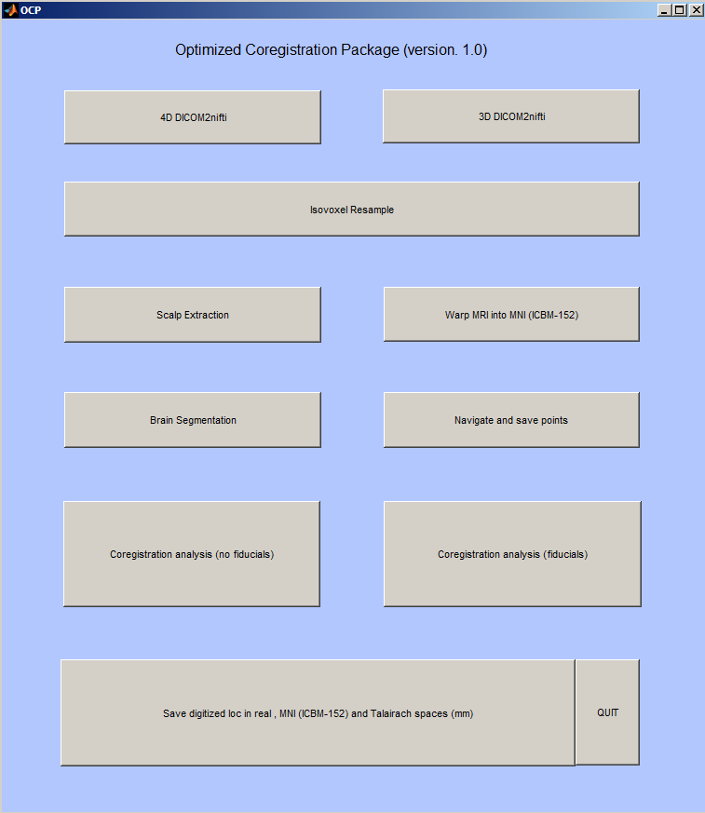

The major number of these stages needs to be performed in order to obtain the final results, others are utility functions:

(1) DICOM2nifti: This function allows converting MRI raw slices into nifti format (3D or 4D images).

(2) Isovoxel Resample: This function transforms the MRI image into a 1mm (0.5 mm High Resolution) iso-voxel image.

(3) Scalp Extraction: Extract the scalp from the MRI structural Image. This scalp will be used for surface iterative fitting procedures if used.

(4) Warp MRI into MNI: This procedure warps the real space structural image into MNI space returning the warped image and the affine transformation (use spm8 function).

(5) Brain segmentation (utility): Extract the white and grey matter from anatomical image (uses spm8 function, can take several minutes).

(6) Navigate and save points (needed, utility): this function allows the user to navigate into the image and save points selected. The procedure is needed when fiducials alignment is performed.

(7) Co-registration analysis (no fiducials, fiducials): This step performs the actual co-registration using different co-registration procedure. At this stage the user is supposed to select a co-registration without fiducials alignment (no fiducials), or with fiducials alignment (Fiducials).

(8)Save digitized loc…: This step allows saving the co-registered digitized location into real space, MNI space and Talairach template.

OCP instructions

**1) DICOM2nifti (DICOM2nift.m)**

This function convert DICOM scans to nifti image using mricron dcm2nii software.

It asks to select one dicom scan of the slices you want to convert in to nifti format. Navigate to the right folder and select any .dcm or .ima file from the original MPRAGE folder.

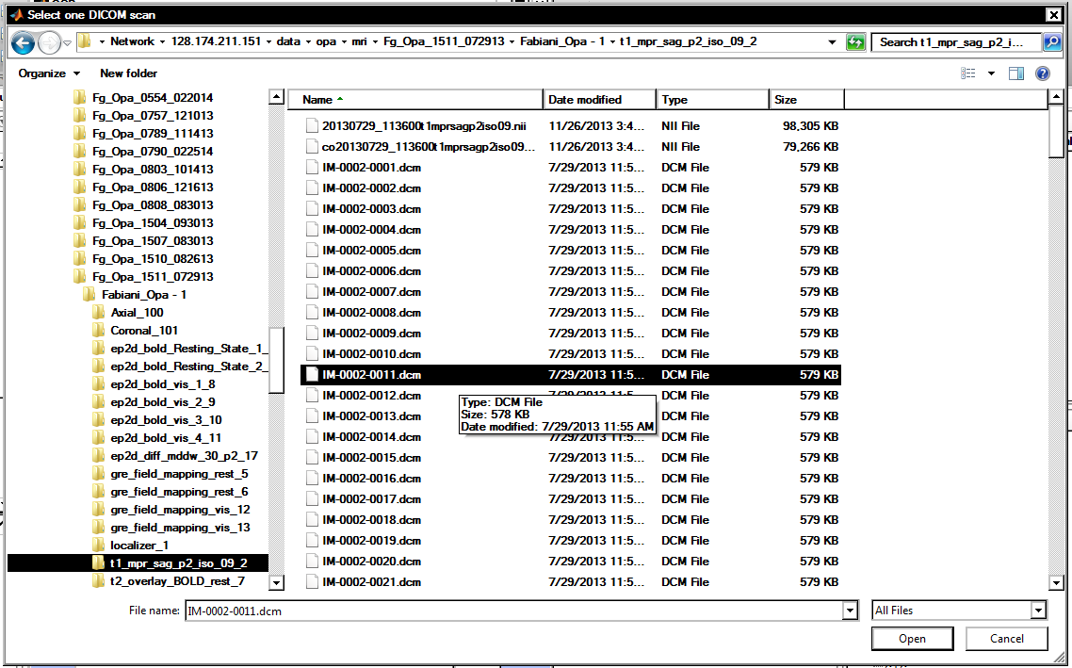

After conversion occurred the images are renamed as function of the information entered by the user and an output directory need to be chosen. This procedure will create three images:

An original converted one (1) …nii, an oriented one (2) o…nii, a cropped and oriented one (3) co...nii.

You must use the image o…nii for further analysis (which is in left-right, posterior-anterior, inferior-superior space, LPI).

**2) Isovoxel resampling (ISOVOX.m)**

-This function transforms oriented (LPI) MRI nifti image to isovoxel (1mm and 0.5 mm) space.

Select the structural image o..._; the program asks you if you want to save a high-resolution image (0.5 mm isovoxel, can take several minutes to generate).

Different nifti image are created:

-o... _R.nii : 1mm LPI Resample image (used for co-registering purposes)

- o... _HR.nii: 0.5mm LPI Resample image (good for accurate brain segmentation in FSL).

**3) Scalp Extraction (SCALP_EXTRACTION.m)**

This algorithm extract scalp surface from a structural MRI image both as points in space and a 3D image. Select an isovoxel image (usually o... _R).

A scalp extraction algorithm is applied and an image is displayed. A default threshold is used for the first scalp extraction.



Check the scalp extraction results and adjust the threshold if the extraction is not satisfying (default 0.05, Chiarelli et al., 2015)

As the user press enter a matlab variable is saved as:

o... _R_scalp.mat

**4) Warp MRI into MNI (warp2MNI.m)**

This function warps an anatomical image into MNI space using a SPM8 function.

The program will ask to select a nifti anatomical image (chose o... _R.nii for coregistration purposes).

After the warping an MRI warped image is saved as w... _R.nii and the affine transformation matrixes are saved as ... _R_sn.mat.

**5) Brain segmentation**

This function segments an anatomical image returning the white and grey matter using spm8 function, the process may take several minutes. Images are saved as c1……ni and c2…..nii.

**6) Navigate and save points (SAVE_POINTS.m; calls MRI_PLOT_GUI.m)**

This function ask you to select an MRI nifti image (for coregistration select o…. _R.nii) and display it suing MRI_PLOT_GUI function.

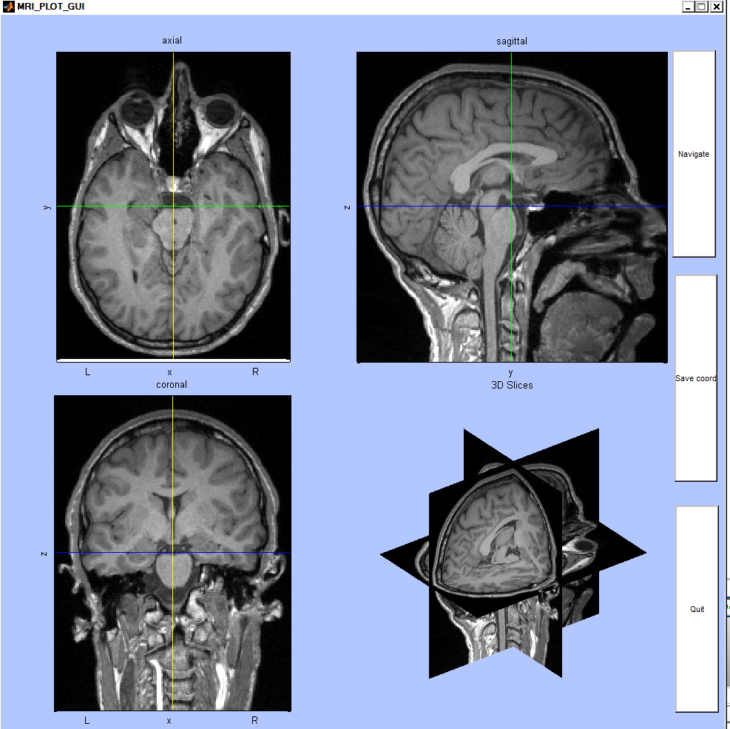

You are allowed to navigate in the image by clicking the “Navigate” button and left clicking on the MRI slices. By left clicking the cross that identified the selected point turns red and you can save the coordinate by clicking the “ Save Coord” button.



Repeat the procedure N wanted points are saved. Click the “Quit” button when you are done. If you need the fiducials alignment select the 3 fiducials that you used when you digitized the point on the scalp. Normally the Nasion and the two pre-auricular points are chosen. Save the coordinate of these points in the same order as you digitized them. The points selected and saved are stored as ….points.mat (usually o…. _R_points.mat).

**7) Coregistration analysis (no fiducials, fiducials) (COREG_ANALYSIS_fid.m)**

These functions perform realignment to real anatomical MRI space using different methods.

If you chose the co-registration algorithm without fiducials the program asks to choose the extracted scalp (usually o….. _R_scalp.mat ), and the digitized points.

The format supported for the digitized points is the elp format. A text file with the extention .elp is needed and the text file should look like the following:

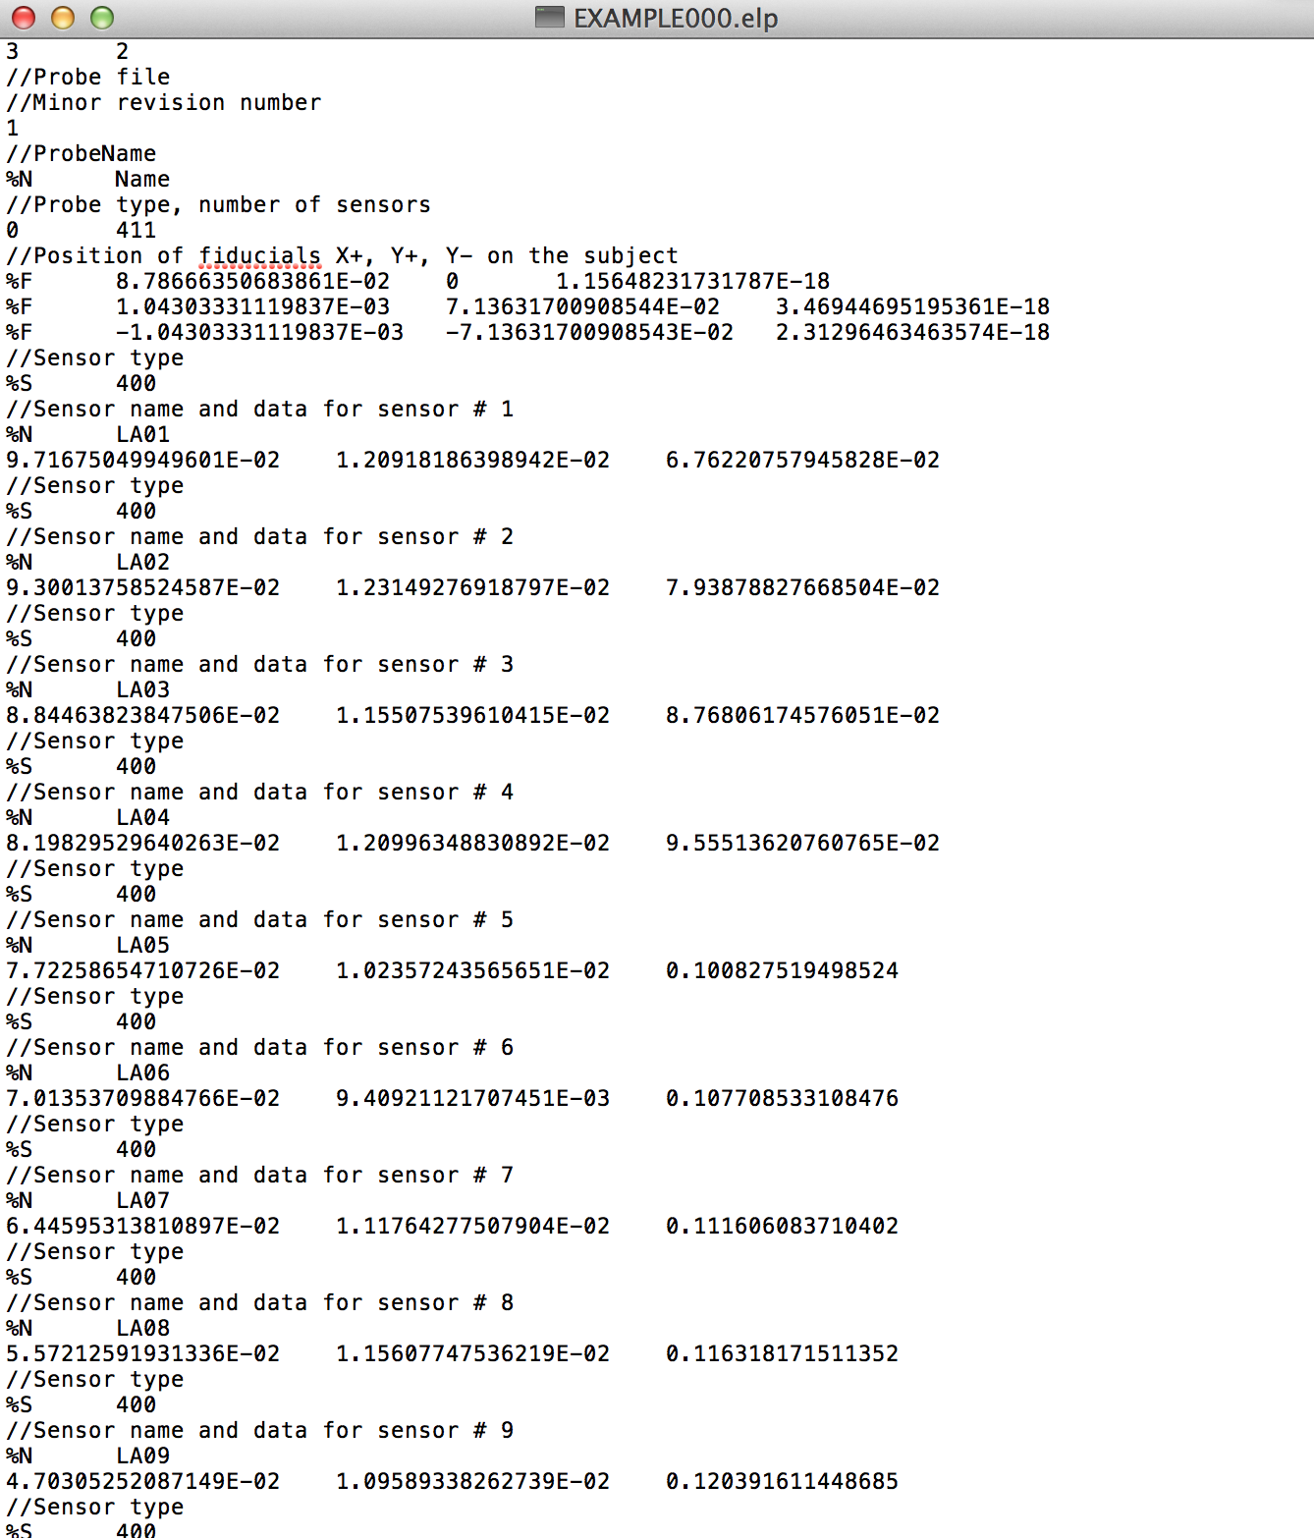

where three fiducial points are recorded and N digitized points saved.

The distances need to be expressed in meters.

If you have other format of digitized points please contact us at [chiarell@illinois.edu](mailto:chiarell@illinois.edu) and we will implement new format reading.

Moreover the program asks you the orientation of the digitized points: the example data are in PRI space thus you need to digitized “PRI” or whatever other space orientation and press enter. The program will re-orient the points into LPI space to avoid reflection errors and others.

Without fiducials the coregistration procedure will be: First moment initial guess alignment+ surface fitting ICP2P+ surface fitting LMA (refer to Chiarelli et al., 2015)

If you choose fiducials alignment the fiducials points selected on the MRI image need to be loaded (….points.mat).

Different method of coregistration can be chosen

1) LMA (Levenberg-Marquardt ),

2) ICP2P (iterative Point-to-Plane)

3)ICP2P+LMA (both)

4) No surface fitting (just fid.))

Refer to Chiarelli et al., 2015 for the method that best fits your data.

After the co-registration procedure, if you want, an image is displayed with different angles of view of scalp with the co-registered points. Some co-registration outcome are reported (as the Root Mean Square Error, RMS).



Finally Data are stored as …scalp_dig_nofid.mat (if you did not used fid alignment) or scalp_dig_fid.mat (if you used fiducials alignment). Data are expressed in mm.

**8) Optode_REAL2MNI_TAI.m**

This last function transforms digitized location from real into MNI and Talairach spaces.

. MNI transformation is performed by using the normalizing procedure implemented in SPM8 and then by applying the resulting affine matrix to the coregistered real space digitized sensor points. Talairach trasformation is performed by applying the affine matrix described by Lancaster et al. (2007) to the MNI coregistered locations

You need to select the anatomical co-registered image (usually, o... _R.nii), the scalp extracted digitized location to the anatomical co-registered image (usually, o..._ _R_scalp_dig.nii), the affine transformation that was reported in the warp2MNI process (usually, o..._R_sn.mat) and the digitized points original file (usually, .elp extension).

Then you need to choose if you want to use the scalp forced points or just the coregistered ones.

These points are transformed into MNI and Talairach spaces using affine matrix transformation (Chiarelli et al 20) and displayed in the three spaces with a guessed Anterior Commisure (AC) point, derived using spm8 function.

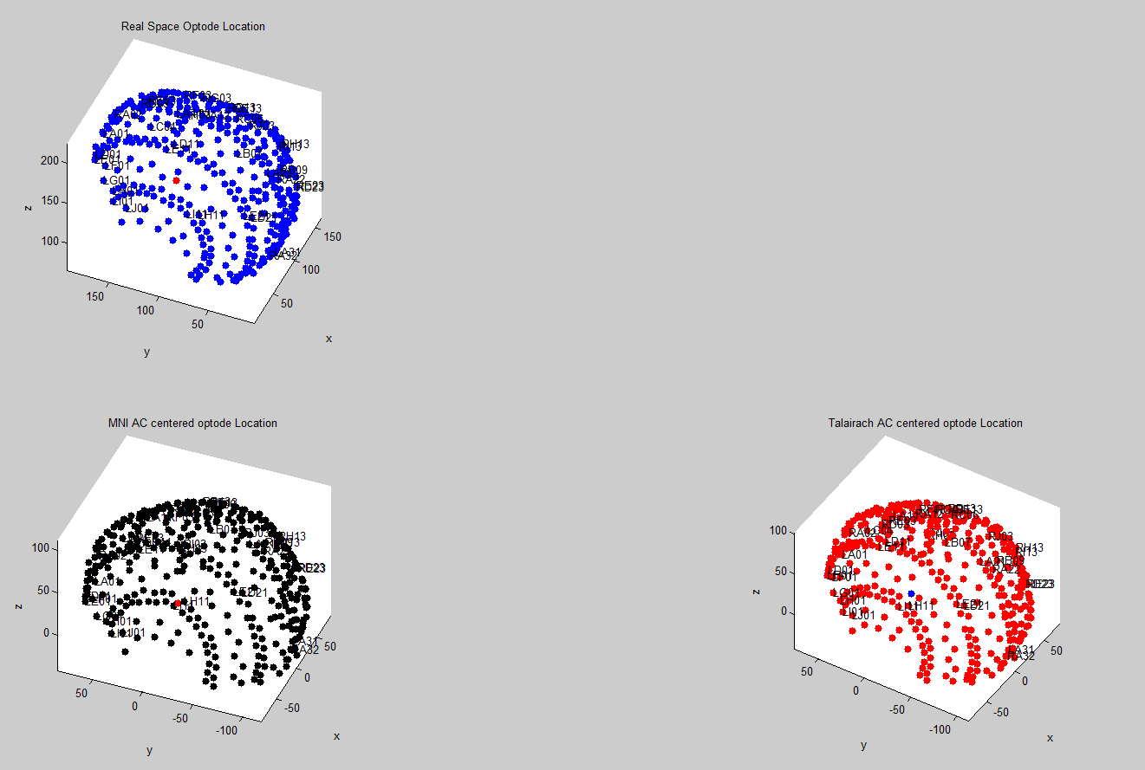

Three text file are saved as:

…_scalp_dig.rol (real optimized locations), …_scalp_dig.mol (MNI optimized locations), …_scalp_dig.tol (Talairach optimized locations.)

The text files look like:



And the distances are expressed in mm.