In this webpage (http://preprocessed-connectomes-project.org/abide/download.html), you can find the instructions as follows
“An example python script for downloading a subset of the data based on participant demographics is available here (right click and select Save Link As...). You can find instructions for using this script here.”

According to the instructions, I download the file namely download_abide_preproc.py from the link of https://github.com/preprocessed-connectomes-project/abide/blob/master/download_abide_preproc.py. The instructions of how to use the file of “download_abide_preproc.py” can be found in https://raw.githubusercontent.com/preprocessed-connectomes-project/abide/master/download_abide_preproc_guide.txt

For example, I enter a command in the Command Prompt window to read the data at the site of Carnegie Mellon University
python G:/download_abide_preproc.py -d rois_cc200 -p cpac -s nofilt_noglobal -o G:/ABIDE1_File –t CMU

I found that I can only get the data of 5 subjects.
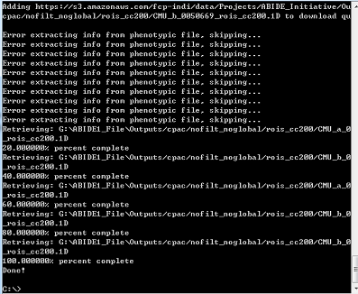
(In G:/ABIDE1_File, I found following data of 5 subjects.)
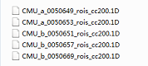

I check the number of subjects at the site of Carnegie Mellon University with following link http://fcon_1000.projects.nitrc.org/indi/abide/abide_I.html. I found the total sample size is 27.


I don’t know why I cannot download all the data from the site of Carnegie Mellon University. Same problem can be found when I tried to download the data from other sites.

Another problem is how to load the downloaded data (e.g., CMU_a_0050649_rois_cc200.1D) into Matlab. I can use “import” menu of Matlab software to import the data. But when I try to use the command (e.g. load), it does not work.

Would you please give me some suggestions? Thank you

