Image 1 – connectivity matrices (CMs)

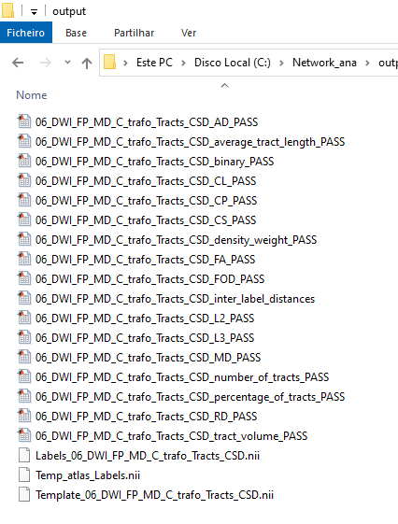
Image 2 – adding CMs (C/Network_ana/output) and BCT (C/Network_ana/output) folders to matlab

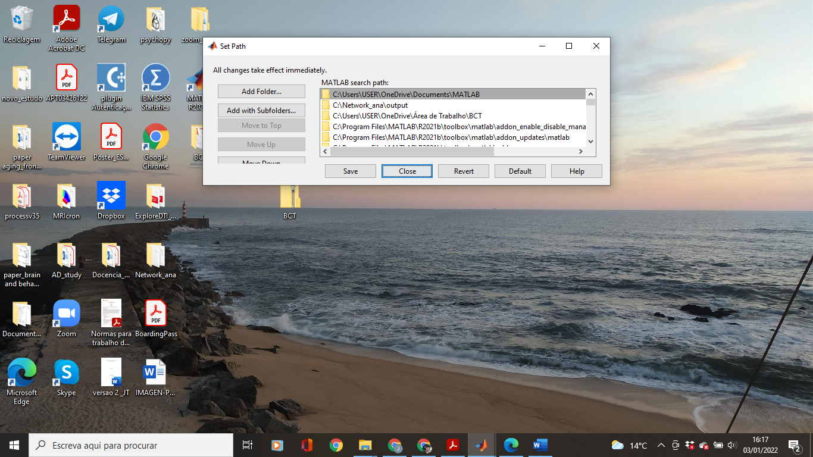
Image 3 – error when computing the efficiency measures in the command window