Flipped Subject

Setup (Functional) Denoising
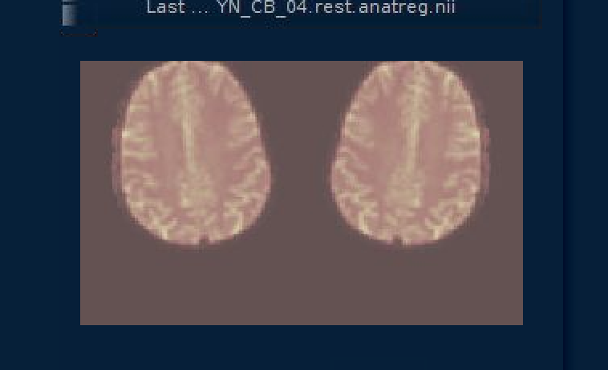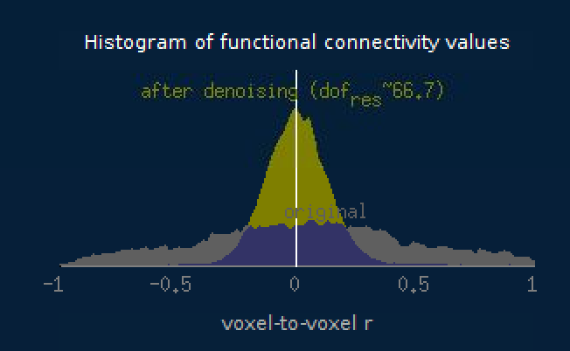
Just one example but all of flipped subjects were like this

Non-Flipped Subject

Setup (Functional) Denoising
