Firstly, I get the colormap file (.vtk), that It is attached below, using the Model to Model distance Module

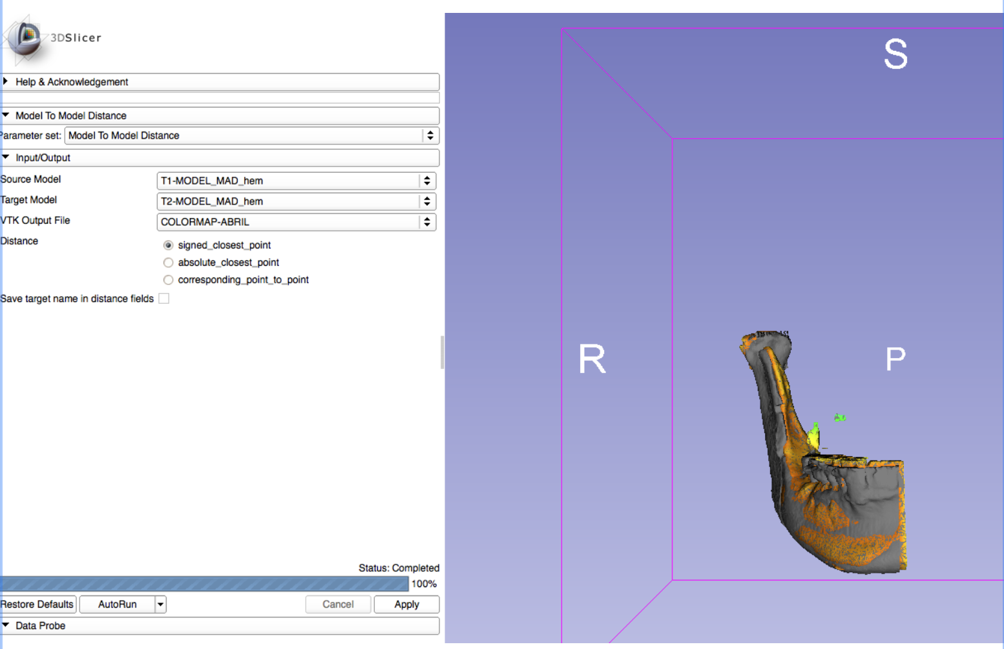

Then, I try to use the Shape Analysis Module but the status says “completed with errors”

Maybe, I am not clicking or selecting the correct parameters

