Errors – 10 Jan 2018
- Cannot run preprocessing on 2 sessions – switched to 1 sequence per project (total 3)
- Error with coregistration? Up to slice timing is fine, segmentation step has issues (see below)
- Files have wau in front of name,

Subject 1 and 2 messed up, the others seem fine. (see below)

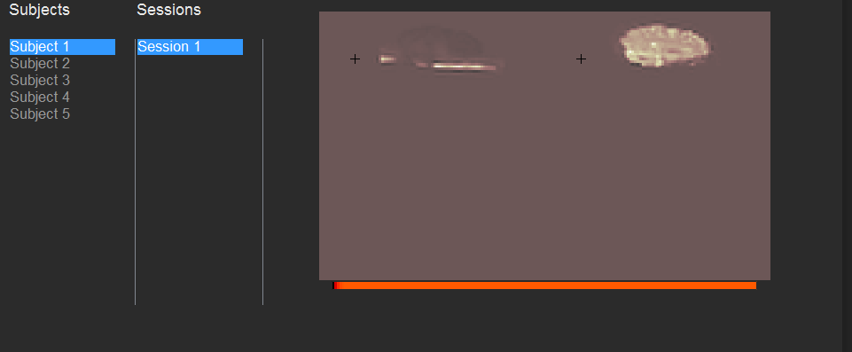
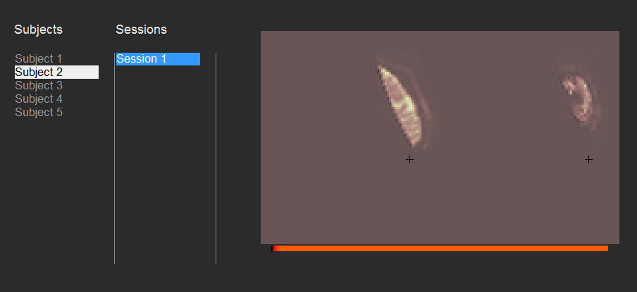

Cannot recognise my nifiti file even though the data type is int16
Preprocessing stopped up to the image calculator (see below). It refers to a unknown Datatype? (NaN)
