OUTPUT components of NBS
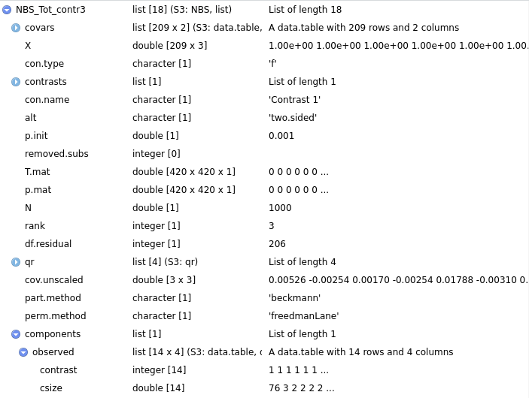
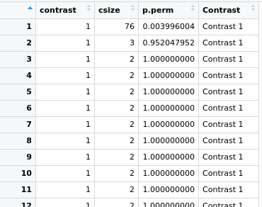

After I insert the T.mat here (part of NBS code package):
clusts <- components(graph_from_adjacency_matrix(T.max[, , j], diag=FALSE,
mode='undirected', weighted=TRUE))

I get the components extracted from the T.mat:
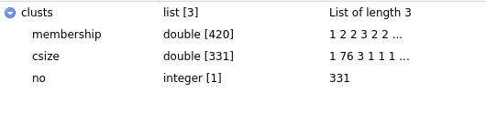
I have 420 egdes. Like you can see each edge is associated to a component. Indeed:
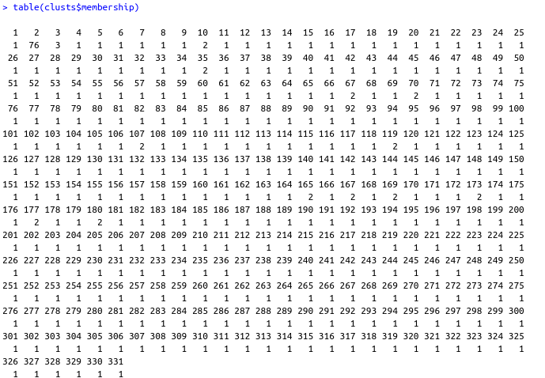
Like you can see, I get the component 2 is formed from 76 nodes (which is the same result I got as NBS output).

