Figure 1. Contrast analysis. On column “sd1”, values 1 for subgroup A and 0 for subgroup B with age controlled.
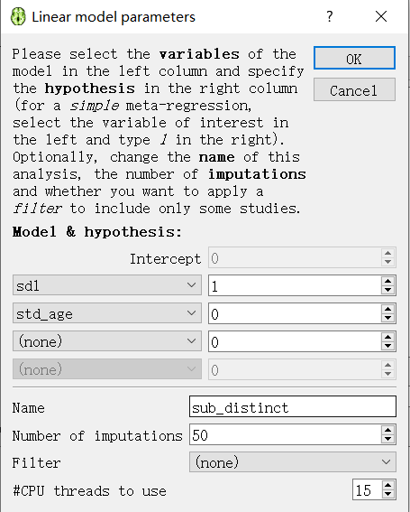

Figure 2. Conjunctive analysis
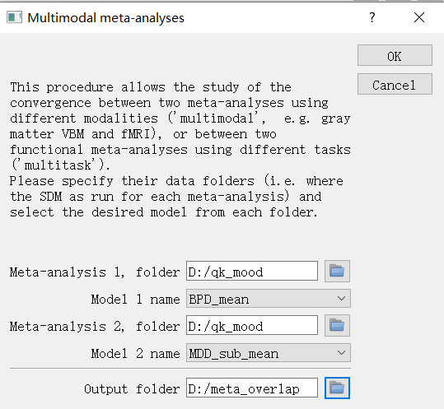
Figure 3. Folder name for conjunctive analysis
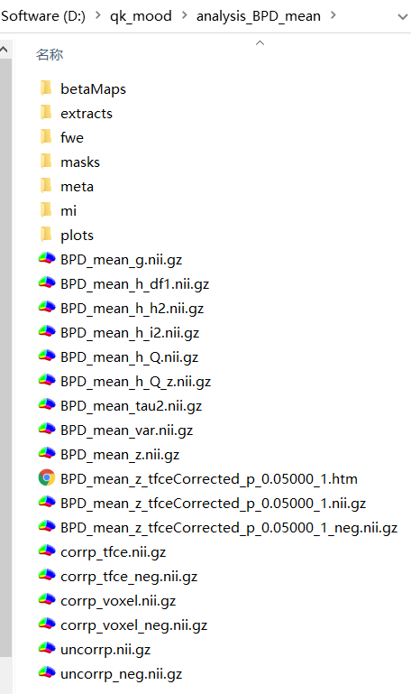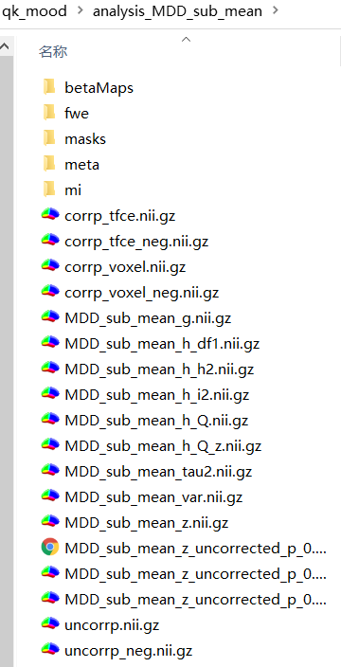

Warning information
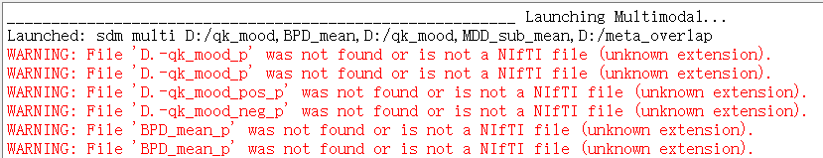
Launched: sdm multi D:/qk_test,BD,D:/qk_test,MDD,D:/meta_overlap
WARNING: File 'D.-qk_test_p' was not found or is not a NIfTI file (unknown extension).
WARNING: File 'D.-qk_test_p' was not found or is not a NIfTI file (unknown extension).
WARNING: File 'D.-qk_test_pos_p' was not found or is not a NIfTI file (unknown extension).
WARNING: File 'D.-qk_test_neg_p' was not found or is not a NIfTI file (unknown extension).
WARNING: File 'BD_p' was not found or is not a NIfTI file (unknown extension).
WARNING: File 'BD_p' was not found or is not a NIfTI file (unknown extension).
WARNING: File 'BD_pos_p' was not found or is not a NIfTI file (unknown extension).
WARNING: File 'BD_neg_p' was not found or is not a NIfTI file (unknown extension).
WARNING: File 'D.-qk_test_pos_p' was not found or is not a NIfTI file (unknown extension).
WARNING: File 'D.-qk_test_pos_BD_pos_p' was not found or is not a NIfTI file (unknown extension).
WARNING: File 'D.-qk_test_pos_BD_pos_p' was not found or is not a NIfTI file (unknown extension).
WARNING: File 'D.-qk_test_pos_BD_pos_p' was not found or is not a NIfTI file (unknown extension).
WARNING: File 'D.-qk_test_pos_BD_pos_p' was not found or is not a NIfTI file (unknown extension).
WARNING: File 'temp1' was not found or is not a NIfTI file (unknown extension).
WARNING: File 'temp1' was not found or is not a NIfTI file (unknown extension).
WARNING: File 'D.-qk_test_pos_BD_pos_p' was not found or is not a NIfTI file (unknown extension).
WARNING: File 'D.-qk_test_pos_BD_pos_p_0.00250' was not found or is not a NIfTI file (unknown extension).
WARNING: File 'D.-qk_test_pos_BD_pos_p_0.00250_0.00025' was not found or is not a NIfTI file (unknown extension).
WARNING: File 'D.-qk_test_pos_BD_pos_p_0.00250_0.00025_10' was not found or is not a NIfTI file (unknown extension).
WARNING: File 'D.-qk_test_pos_p' was not found or is not a NIfTI file (unknown extension).
WARNING: File 'D.-qk_test_pos_BD_neg_p' was not found or is not a NIfTI file (unknown extension).
WARNING: File 'D.-qk_test_pos_BD_neg_p' was not found or is not a NIfTI file (unknown extension).
WARNING: File 'D.-qk_test_pos_BD_neg_p' was not found or is not a NIfTI file (unknown extension).
WARNING: File 'D.-qk_test_pos_BD_neg_p' was not found or is not a NIfTI file (unknown extension).
WARNING: File 'temp1' was not found or is not a NIfTI file (unknown extension).
WARNING: File 'temp1' was not found or is not a NIfTI file (unknown extension).
WARNING: File 'D.-qk_test_pos_BD_neg_p' was not found or is not a NIfTI file (unknown extension).
WARNING: File 'D.-qk_test_pos_BD_neg_p_0.00250' was not found or is not a NIfTI file (unknown extension).
WARNING: File 'D.-qk_test_pos_BD_neg_p_0.00250_0.00025' was not found or is not a NIfTI file (unknown extension).
WARNING: File 'D.-qk_test_pos_BD_neg_p_0.00250_0.00025_10' was not found or is not a NIfTI file (unknown extension).
WARNING: File 'D.-qk_test_neg_p' was not found or is not a NIfTI file (unknown extension).
WARNING: File 'D.-qk_test_neg_BD_pos_p' was not found or is not a NIfTI file (unknown extension).
WARNING: File 'D.-qk_test_neg_BD_pos_p' was not found or is not a NIfTI file (unknown extension).
WARNING: File 'D.-qk_test_neg_BD_pos_p' was not found or is not a NIfTI file (unknown extension).
WARNING: File 'D.-qk_test_neg_BD_pos_p' was not found or is not a NIfTI file (unknown extension).
WARNING: File 'temp1' was not found or is not a NIfTI file (unknown extension).
WARNING: File 'temp1' was not found or is not a NIfTI file (unknown extension).
WARNING: File 'D.-qk_test_neg_BD_pos_p' was not found or is not a NIfTI file (unknown extension).
WARNING: File 'D.-qk_test_neg_BD_pos_p_0.00250' was not found or is not a NIfTI file (unknown extension).
WARNING: File 'D.-qk_test_neg_BD_pos_p_0.00250_0.00025' was not found or is not a NIfTI file (unknown extension).
WARNING: File 'D.-qk_test_neg_BD_pos_p_0.00250_0.00025_10' was not found or is not a NIfTI file (unknown extension).
WARNING: File 'D.-qk_test_neg_p' was not found or is not a NIfTI file (unknown extension).
WARNING: File 'D.-qk_test_neg_BD_neg_p' was not found or is not a NIfTI file (unknown extension).
WARNING: File 'D.-qk_test_neg_BD_neg_p' was not found or is not a NIfTI file (unknown extension).
WARNING: File 'D.-qk_test_neg_BD_neg_p' was not found or is not a NIfTI file (unknown extension).
WARNING: File 'D.-qk_test_neg_BD_neg_p' was not found or is not a NIfTI file (unknown extension).
WARNING: File 'temp1' was not found or is not a NIfTI file (unknown extension).
WARNING: File 'temp1' was not found or is not a NIfTI file (unknown extension).
WARNING: File 'D.-qk_test_neg_BD_neg_p' was not found or is not a NIfTI file (unknown extension).
WARNING: File 'D.-qk_test_neg_BD_neg_p_0.00250' was not found or is not a NIfTI file (unknown extension).
WARNING: File 'D.-
WARNING: File 'D.-qk_mood_p' was not found or is not a NIfTI file (unknown extension).
WARNING: File 'D.-qk_mood_p' was not found or is not a NIfTI file (unknown extension).
WARNING: File 'D.-qk_mood_pos_p' was not found or is not a NIfTI file (unknown extension).
WARNING: File 'D.-qk_mood_neg_p' was not found or is not a NIfTI file (unknown extension).
WARNING: File 'BPD_mean_p' was not found or is not a NIfTI file (unknown extension).
WARNING: File 'BPD_mean_p' was not found or is not a NIfTI file (unknown extension).
WARNING: File 'BPD_mean_pos_p' was not found or is not a NIfTI file (unknown extension).
WARNING: File 'BPD_mean_neg_p' was not found or is not a NIfTI file (unknown extension).
WARNING: File 'D.-qk_mood_pos_p' was not found or is not a NIfTI file (unknown extension).
WARNING: File 'D.-qk_mood_pos_BPD_mean_pos_p' was not found or is not a NIfTI file (unknown extension).
WARNING: File 'D.-qk_mood_pos_BPD_mean_pos_p' was not found or is not a NIfTI file (unknown extension).
WARNING: File 'D.-qk_mood_pos_BPD_mean_pos_p' was not found or is not a NIfTI file (unknown extension).
WARNING: File 'D.-qk_mood_pos_BPD_mean_pos_p' was not found or is not a NIfTI file (unknown extension).
WARNING: File 'temp1' was not found or is not a NIfTI file (unknown extension).
WARNING: File 'temp1' was not found or is not a NIfTI file (unknown extension).
WARNING: File 'D.-qk_mood_pos_BPD_mean_pos_p' was not found or is not a NIfTI file (unknown extension).
WARNING: File 'D.-qk_mood_pos_BPD_mean_pos_p_0.00250' was not found or is not a NIfTI file (unknown extension).
WARNING: File 'D.-qk_mood_pos_BPD_mean_pos_p_0.00250_0.00025' was not found or is not a NIfTI file (unknown extension).
WARNING: File 'D.-qk_mood_pos_BPD_mean_pos_p_0.00250_0.00025_10' was not found or is not a NIfTI file (unknown extension).
WARNING: File 'D.-qk_mood_pos_p' was not found or is not a NIfTI file (unknown extension).
WARNING: File 'D.-qk_mood_pos_BPD_mean_neg_p' was not found or is not a NIfTI file (unknown extension).
WARNING: File 'D.-qk_mood_pos_BPD_mean_neg_p' was not found or is not a NIfTI file (unknown extension).
WARNING: File 'D.-qk_mood_pos_BPD_mean_neg_p' was not found or is not a NIfTI file (unknown extension).
WARNING: File 'D.-qk_mood_pos_BPD_mean_neg_p' was not found or is not a NIfTI file (unknown extension).
WARNING: File 'temp1' was not found or is not a NIfTI file (unknown extension).
WARNING: File 'temp1' was not found or is not a NIfTI file (unknown extension).
WARNING: File 'D.-qk_mood_pos_BPD_mean_neg_p' was not found or is not a NIfTI file (unknown extension).
WARNING: File 'D.-qk_mood_pos_BPD_mean_neg_p_0.00250' was not found or is not a NIfTI file (unknown extension).
WARNING: File 'D.-qk_mood_pos_BPD_mean_neg_p_0.00250_0.00025' was not found or is not a NIfTI file (unknown extension).
WARNING: File 'D.-qk_mood_pos_BPD_mean_neg_p_0.00250_0.00025_10' was not found or is not a NIfTI file (unknown extension).
WARNING: File 'D.-qk_mood_neg_p' was not found or is not a NIfTI file (unknown extension).
WARNING: File 'D.-qk_mood_neg_BPD_mean_pos_p' was not found or is not a NIfTI file (unknown extension).
WARNING: File 'D.-qk_mood_neg_BPD_mean_pos_p' was not found or is not a NIfTI file (unknown extension).
WARNING: File 'D.-qk_mood_neg_BPD_mean_pos_p' was not found or is not a NIfTI file (unknown extension).
WARNING: File 'D.-qk_mood_neg_BPD_mean_pos_p' was not found or is not a NIfTI file (unknown extension).
WARNING: File 'temp1' was not found or is not a NIfTI file (unknown extension).
WARNING: File 'temp1' was not found or is not a NIfTI file (unknown extension).
WARNING: File 'D.-qk_mood_neg_BPD_mean_pos_p' was not found or is not a NIfTI file (unknown extension).
WARNING: File 'D.-qk_mood_neg_BPD_mean_pos_p_0.00250' was not found or is not a NIfTI file (unknown extension).
WARNING: File 'D.-qk_mood_neg_BPD_mean_pos_p_0.00250_0.00025' was not found or is not a NIfTI file (unknown extension).
WARNING: File 'D.-qk_mood_neg_BPD_mean_pos_p_0.00250_0.00025_10' was not found or is not a NIfTI file (unknown extension).
WARNING: File 'D.-qk_mood_neg_p' was not found or is not a NIfTI file (unknown extension).
WARNING: File 'D.-qk_mood_neg_BPD_mean_neg_p' was not found or is not a NIfTI file (unknown extension).
WARNING: File 'D.-qk_mood_neg_BPD_mean_neg_p' was not found or is not a NIfTI file (unknown extension).
WARNING: File 'D.-qk_mood_neg_BPD_mean_neg_p' was not found or is not a NIfTI file (unknown extension).
WARNING: File 'D.-qk_mood_neg_BPD_mean_neg_p' was not found or is not a NIfTI file (unknown extension).
WARNING: File 'temp1' was not found or is not a NIfTI file (unknown extension).
WARNING: File 'temp1' was not found or is not a NIfTI file (unknown extension).
WARNING: File 'D.-qk_mood_neg_BPD_mean_neg_p' was not found or is not a NIfTI file (unknown extension).
WARNING: File 'D.-qk_mood_neg_BPD_mean_neg_p_0.00250' was not found or is not a NIfTI file (unknown extension).
WARNING: File 'D.-qk_mood_neg_BPD_mean_neg_p_0.00250_0.00025' was not found or is not a NIfTI file (unknown extension).
WARNING: File 'D.-qk_mood_neg_BPD_mean_neg_p_0.00250_0.00025_10' was not found or is not a NIfTI file (unknown extension). qk_test_neg_BD_neg_p_0.00250_0.00025' was not found or is not a NIfTI file (unknown extension).
WARNING: File 'D.-qk_test_neg_BD_neg_p_0.00250_0.00025_10' was not found or is not a NIfTI file (unknown extension).

