10/09/23
In-vivo (N=11) and ex-vivo (N=10) C57BL anatomical mouse brain atlases are created by Brookhaven National Laboratory and National High Magnetic Field Laboratory research collaboration. 3D volumetric anatomical MRI reference data and corresponding manually delineated labels are shared in nifti image format.
The work has been published (PMID: 16165303 and 18958199) and the authors would like to acknowledge the financial support of the National Institute of Health through grants R01 EB 00233–04 and P41 RR16105 and the National High Magnetic Field Laboratory.

Left/right handedness is shown below.
Images are visualized by MRIcron software (https://www.nitrc.org/projects/mricron)

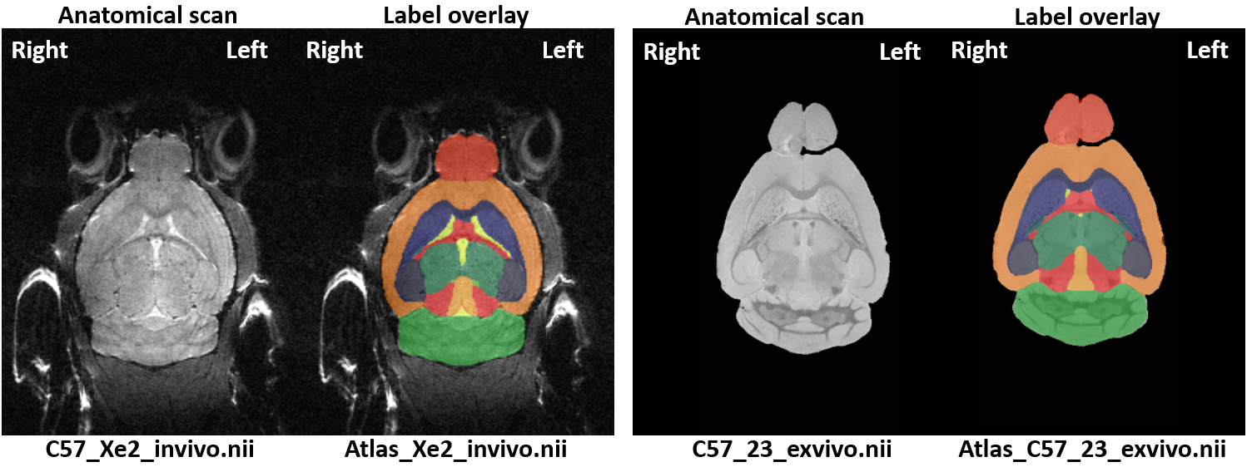

Label image intensity | Anatomical landmark
1 | Hippocampus
2 | Corpus callosum and external capsule
3 | Caudate
4 | Anterior commissure
5 | Globus pallidus
6 | Internal capsule
7 | Thalamus
8 | Cerebellum
9 | Superior Colliculi
10 | Ventricles
11 | Hypo-Thalamus
12 | Inferior Colliculus
13 | Central gray matter
14 | Cortex
15 | Amygdala
16 | Olfactory Bulb
17 | Brain Stem
18 | Rest of midbrain
19 | Basal forebrain septum
20 | Fimbria

For inquiries, please contact helene.benveniste@yale.edu or hedok.lee@yale.edu .

